

Second Sunday of Easter

CHRIST LUTHERAN CHURCH | Lodi, California
April 12, 2026

WELCOME TO WORSHIP
Welcome to Christ Lutheran Church. We pray that your soul will be strengthened by the good news about God’s grace, love, and forgiveness given to us. If you would like to learn more about our church, please speak with our pastor or one of our members after the service.
- Bathrooms are located in the fellowship hall. A changing table is located in the women’s bathroom.
WORSHIP THEME
The Easter gift of faith. Christ revealed his resurrected body to his disciples and allowed them to see and touch what their hearts could not believe. Blessed are they who have not seen, and yet their hearts have believed: may we receive the gift of believing hearts through the powerful word of Christ’s gospel.

The Service, Setting I
The high and holy worship of God is faith in Jesus Christ. Such faith is created and sustained by God’s service to us (the German, “Gottesdienst,” “The Divine Service”). In the Divine Service, the Lord comes to us in His Word and Sacrament to bless and enliven us with His gifts. The Service is not something we do for God, but His service to us received in faith. The liturgy is God’s work. He gives, we receive.
HYMN Christ the Lord is Risen Today| CW 465
M: In the name of the Father, and of the Son, and of the Holy Spirit.
C: Amen.

CONFESSION
M: Beloved in the Lord: let us draw near with a true heart and confess our sins to God our Father, asking him in the name of our Lord Jesus Christ to grant us forgiveness.
From God’s Word we know that wherever God puts His name, there He is to bless. In the Old Testament the temple was the place where God graciously caused His name to be present (1 Kings 8:27-30).
God has put His name —Father, Son, and Holy Spirit—on us in Holy Baptism. The Divine Service begins with the Invocation, the words spoken over us at our baptisms. Every Divine Service is for the hallowing of the Lord’s name, which the Small Catechism reminds us is done “when the Word of God is taught in its truth and purity, and we, as the children of God, also lead holy lives according to it” (Matthew 28:18-20).
C: Holy and merciful Father, I confess that I am by nature sinful, and that I have disobeyed you in my thoughts, words, and actions. I have done what is evil and failed to do what is good. For this I deserve your punishment both now and in eternity. But I am truly sorry for my sins, and trusting in my Savior Jesus Christ, I pray: Lord, have mercy on me, a sinner.

absolution
M: God, our heavenly Father, has been merciful to us and has given his only Son to be the atoning sacrifice for our sins. Therefore, as a called servant of Christ and by his authority, I forgive you all your sins in the name of the Father and of the Son ✙ and of the Holy Spirit.
C: Amen

Kyrie
M: In peace let us pray to the Lord.
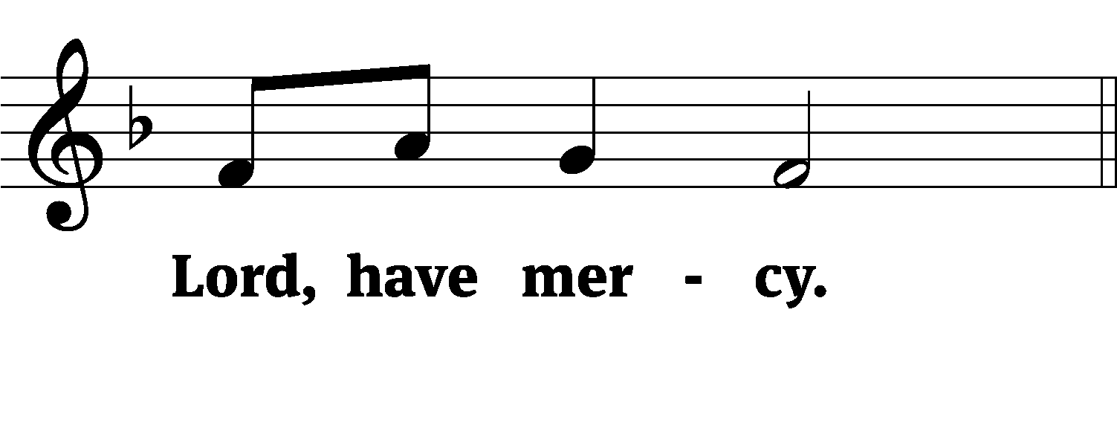
M: For the peace from above and for our salvation, let us pray to the Lord.
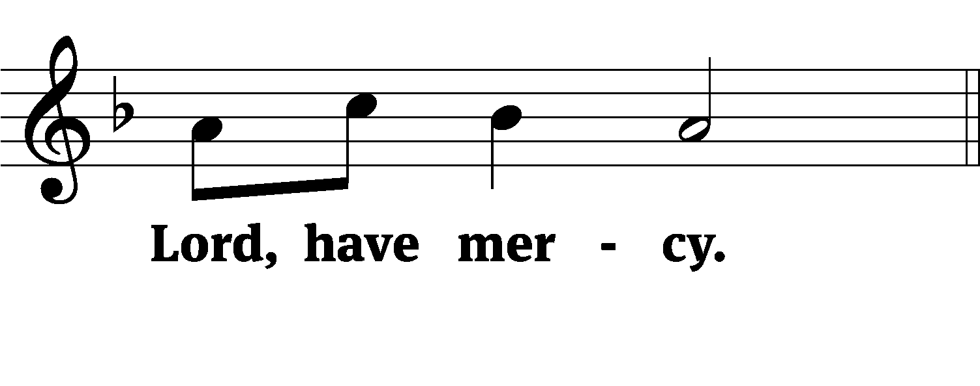
M: For the peace of the whole world, for the well-being of the Church of God, and for the unity of all, let us pray to the Lord.
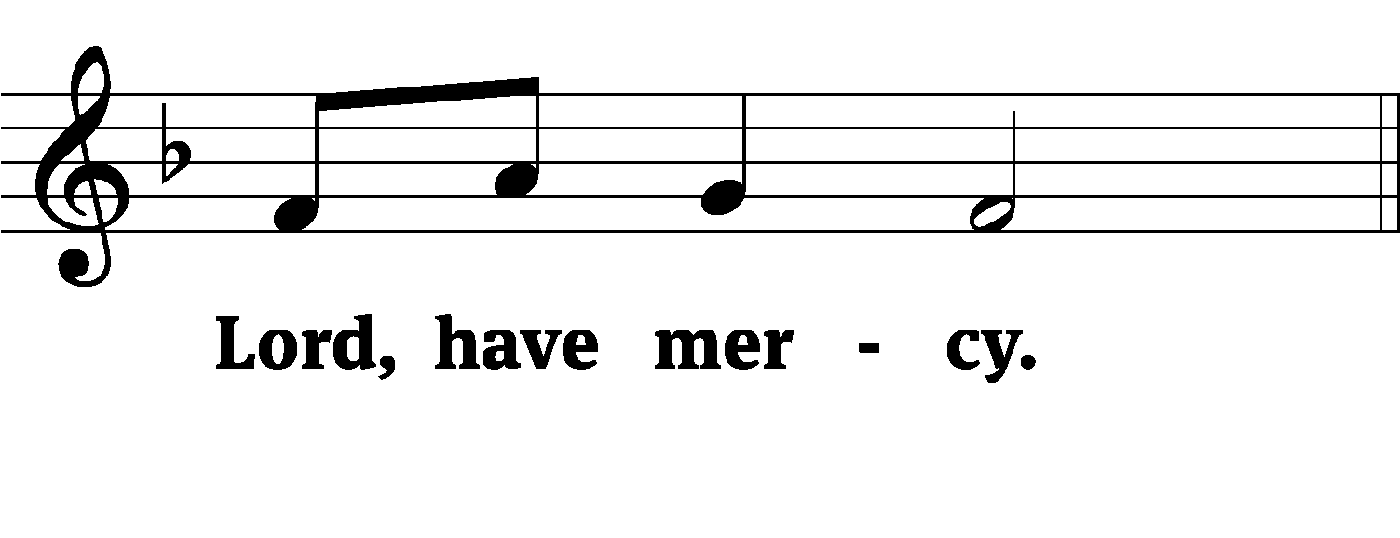
M: For this holy house and for all who offer here their worship and praise, let us pray to the Lord.
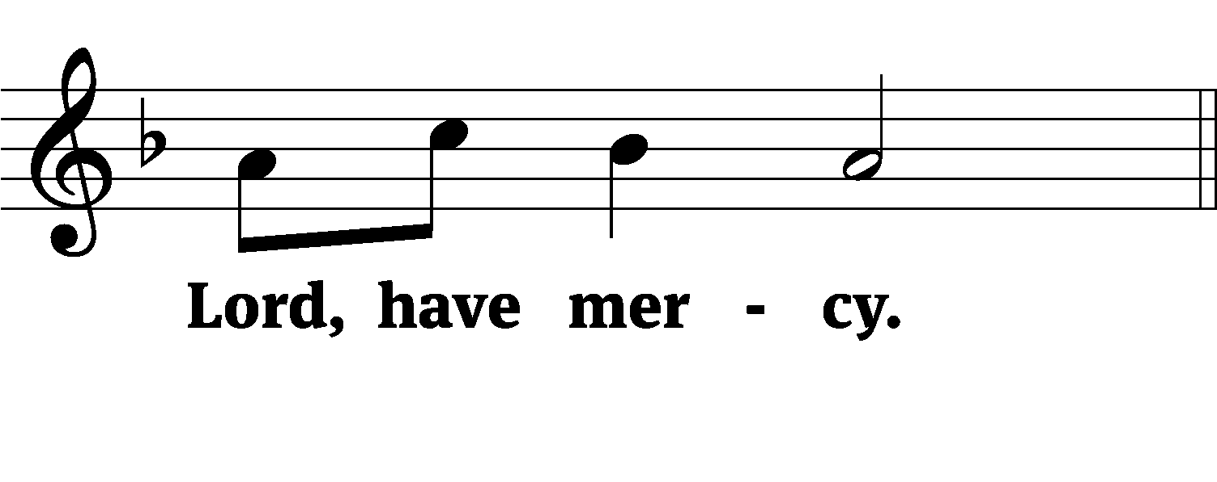
M: Help, save, comfort, and defend us, gracious Lord.
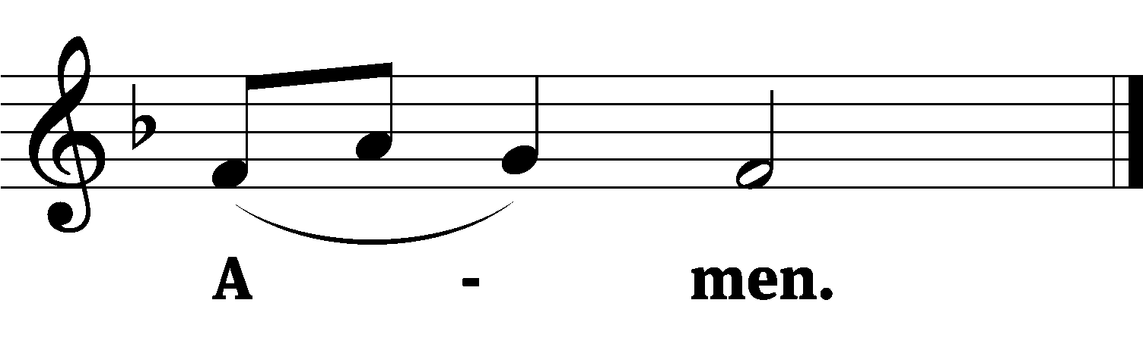

M: Let us praise the Lord.
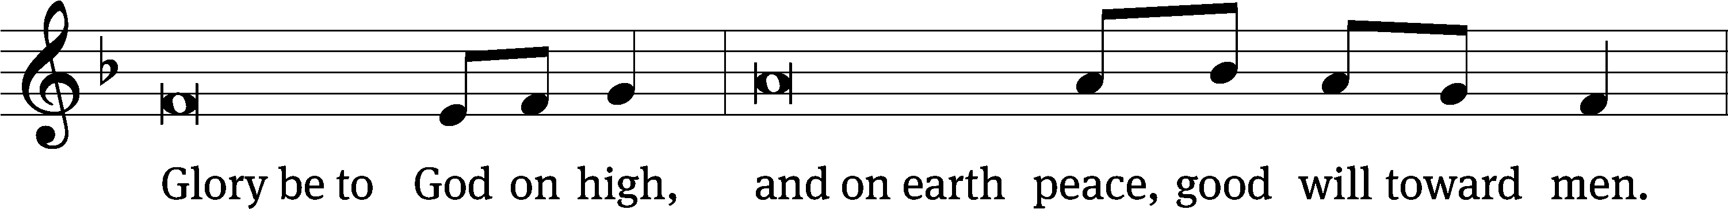
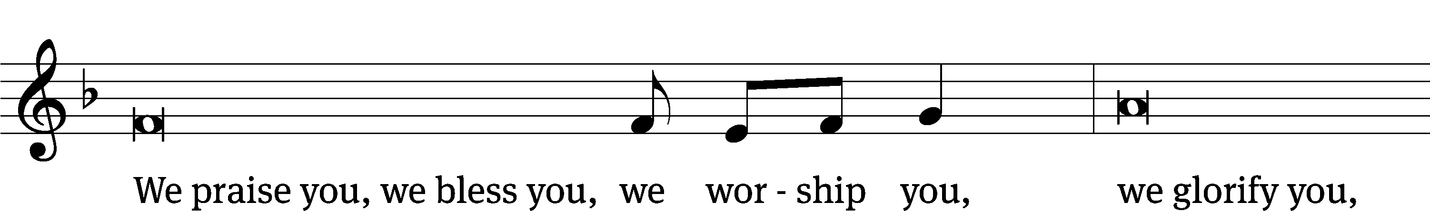
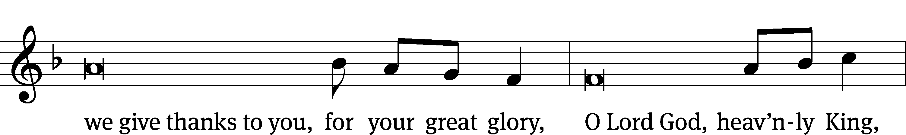
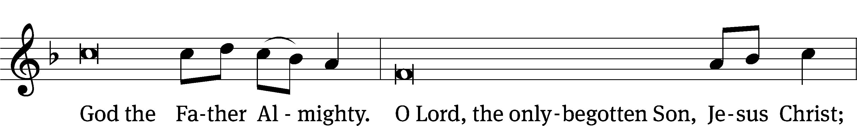

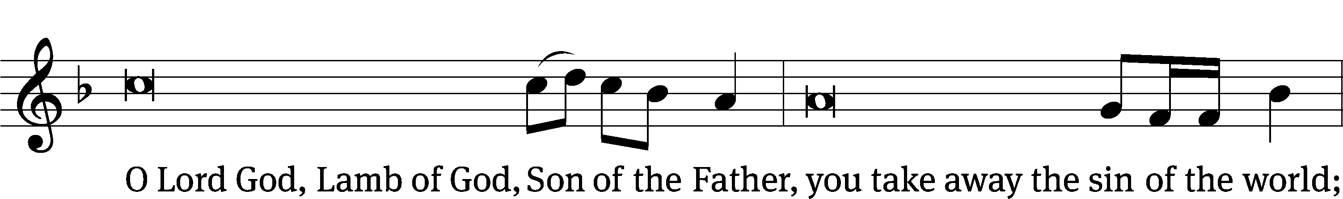
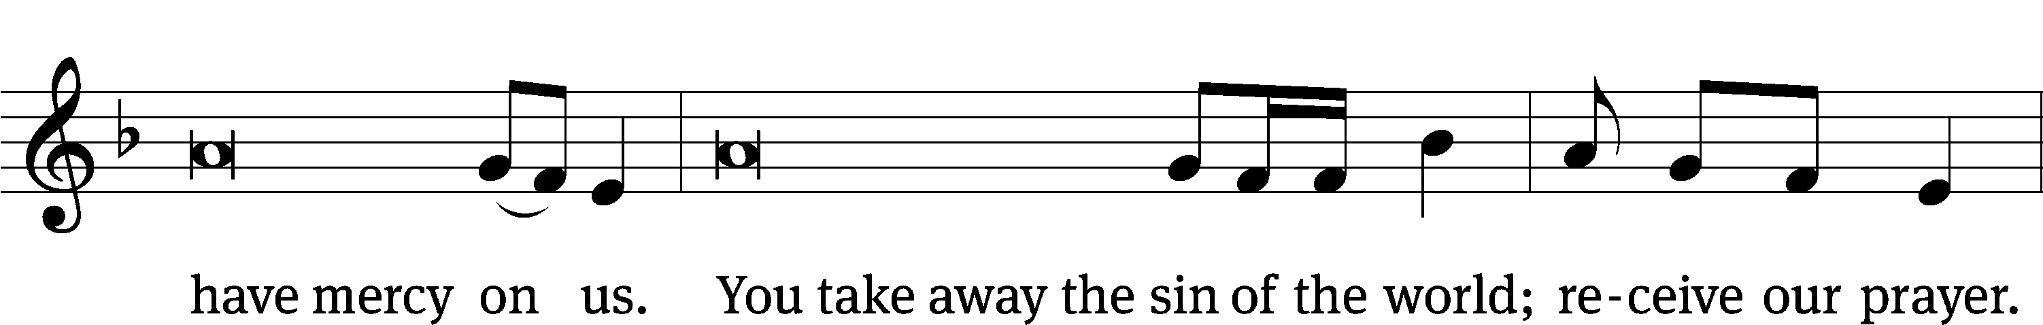
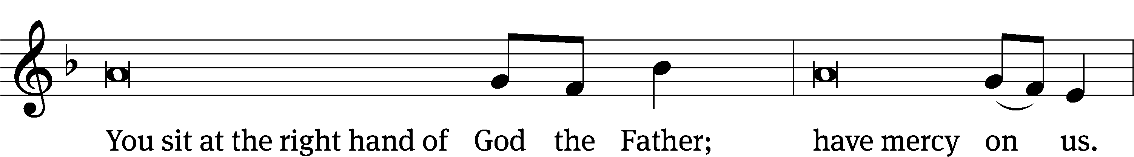
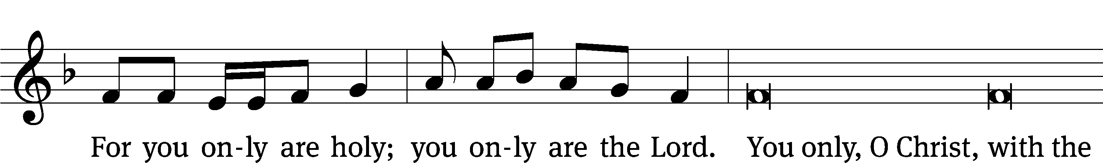
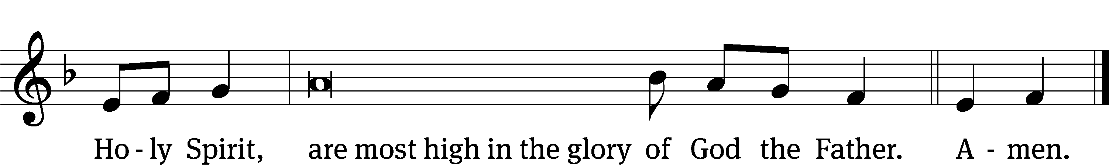
PRAYER OF THE DAY
M: The Lord be with you.
C: And also with you.
M: Let us pray.
O risen Lord, you came to your disciples and took away their fears with your word of peace. Come to us also by Word and sacrament, and banish our fears with the comforting assurance of your abiding presence; for you live and reign with the Father and the Holy Spirit, one God, now and forever.
C: Amen
FIRST LESSON Acts 2:14a,22–32
Peter’s Pentecost Sermon: Trust in the Lord’s Word of Life
Then Peter stood up with the Eleven, raised his voice and addressed the crowd: “Fellow Jews and all of you who live in Jerusalem, let me explain this to you; listen carefully to what I say.
“Fellow Israelites, listen to this: Jesus of Nazareth was a man accredited by God to you by miracles, wonders and signs, which God did among you through him, as you yourselves know. This man was handed over to you by God’s deliberate plan and foreknowledge; and you, with the help of wicked men, put him to death by nailing him to the cross. But God raised him from the dead, freeing him from the agony of death, because it was impossible for death to keep its hold on him. David said about him:
“‘I saw the Lord always before me.
Because he is at my right hand,
I will not be shaken.
Therefore my heart is glad and my tongue rejoices;
my body also will rest in hope,
because you will not abandon me to the realm of the dead,
you will not let your holy one see decay.
You have made known to me the paths of life;
you will fill me with joy in your presence.’
“Fellow Israelites, I can tell you confidently that the patriarch David died and was buried, and his tomb is here to this day. But he was a prophet and knew that God had promised him on oath that he would place one of his descendants on his throne. Seeing what was to come, he spoke of the resurrection of the Messiah, that he was not abandoned to the realm of the dead, nor did his body see decay. God has raised this Jesus to life, and we are all witnesses of it.
PSALM Psalm 16
SECOND LESSON 1 Peter 1:3–9
The gift of resurrection faith brings joy in the midst of suffering.
Praise be to the God and Father of our Lord Jesus Christ! In his great mercy he has given us new birth into a living hope through the resurrection of Jesus Christ from the dead, and into an inheritance that can never perish, spoil or fade. This inheritance is kept in heaven for you, who through faith are shielded by God’s power until the coming of the salvation that is ready to be revealed in the last time. In all this you greatly rejoice, though now for a little while you may have had to suffer grief in all kinds of trials. These have come so that the proven genuineness of your faith—of greater worth than gold, which perishes even though refined by fire—may result in praise, glory and honor when Jesus Christ is revealed. Though you have not seen him, you love him; and even though you do not see him now, you believe in him and are filled with an inexpressible and glorious joy, for you are receiving the end result of your faith, the salvation of your souls.
VERSE OF THE DAY John 20:29
M: Alleluia, Alleluia. Christ is risen!
C: He is risen, indeed! Alleluia!
M: Blessed are those who have not seen and yet have believed.
C: Alleluia.
THE GOSPEL John 20:19–31
Thomas is given faith by the sight of the risen Christ.
On the evening of that first day of the week, when the disciples were together, with the doors locked for fear of the Jewish leaders, Jesus came and stood among them and said, “Peace be with you!” After he said this, he showed them his hands and side. The disciples were overjoyed when they saw the Lord.
Again Jesus said, “Peace be with you! As the Father has sent me, I am sending you.” And with that he breathed on them and said, “Receive the Holy Spirit. If you forgive anyone’s sins, their sins are forgiven; if you do not forgive them, they are not forgiven.”
Now Thomas (also known as Didymus), one of the Twelve, was not with the disciples when Jesus came. So the other disciples told him, “We have seen the Lord!”
But he said to them, “Unless I see the nail marks in his hands and put my finger where the nails were, and put my hand into his side, I will not believe.”
A week later his disciples were in the house again, and Thomas was with them. Though the doors were locked, Jesus came and stood among them and said, “Peace be with you!” Then he said to Thomas, “Put your finger here; see my hands. Reach out your hand and put it into my side. Stop doubting and believe.”
Thomas said to him, “My Lord and my God!”
Then Jesus told him, “Because you have seen me, you have believed; blessed are those who have not seen and yet have believed.”
Jesus performed many other signs in the presence of his disciples, which are not recorded in this book. But these are written that you may believe that Jesus is the Messiah, the Son of God, and that by believing you may have life in his name.
M This is the Gospel of the Lord.
C: Praise be to you, O Christ!
NICENE CREED
We believe in one God, Dt. 6:4
the Father, the Almighty, 2 Cor. 6:18
maker of heaven and earth, Is. 51:13
The Nicene Creed is the great Confession of the Christian faith professed by all Christians. The Creed originated at the First Council of Nicaea (c. AD. 325)
of all that is, seen and unseen. Col. 1:16
We believe in one Lord, Jesus Christ, 1 Cor 8:6
the only Son of God, Jn. 3:16
eternally begotten of the Father, Heb. 1:2,5
God from God, Light from Light, true God from true God, Jn. 1
begotten, not made, of one being with the Father. Jn. 10:30
Through him all things were made. Jn. 1:3
For us and for our salvation, 1 Th. 5:9
he came down from heaven, Jn. 6:38
was incarnate of the Holy Spirit and the virgin Mary, Lk. 1:35
and became fully human. Gal. 4:4
For our sake he was crucified under Pontius Pilate. Mk. 15:15
He suffered death and was buried. 1 Cor. 15:3-4a
On the third day he rose again in accordance
The Creed itself was crafted as a confession of Scripture in opposition to the Arian heresy, which denied that the Lord Jesus and the Holy Spirit are God.

with the Scriptures. 1 Cor. 15:4b
He ascended into heaven Ac. 2:33-34
and is seated at the right hand of the Father. Heb. 1:13
He will come again in glory Mt. 25:31
to judge the living and the dead, 2 Tim. 4:1
and his kingdom will have no end. Lk. 1:33
We believe in the Holy Spirit, the Lord, the giver of life, Job 33:4
who proceeds from the Father and the Son, Jn. 15:26
who in unity with the Father and the Son Jn. 4:24
is worshiped and glorified,
who has spoken through the prophets. 2 Pet. 1:25
We believe in one holy Christian Mt. 16:18; Eph. 2:19-20
and apostolic Church.
We acknowledge one baptism for the forgiveness of sins. Eph. 4:5; Ac. 2:38
We look for the resurrection of the dead 1 Cor. 15:21-22
and the life of the world to come. Amen. Rev. 22
HYMN OF THE DAY O Sons and Daughters of the King| CW 456, vv. 1,4–9
SERMON John 20
OFFERTORY
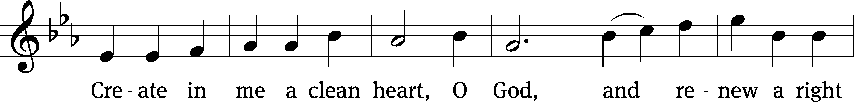
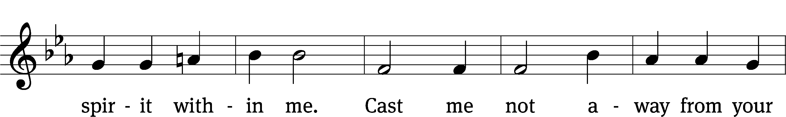
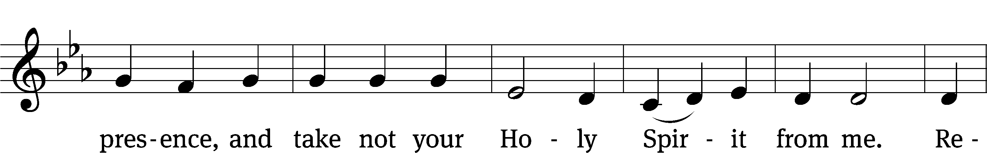
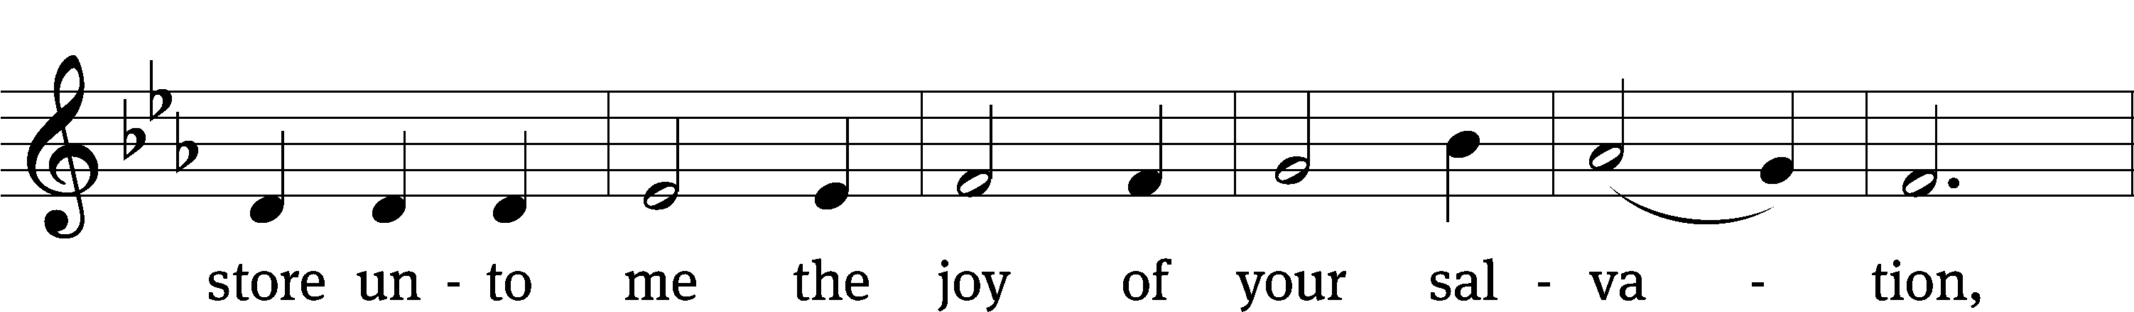
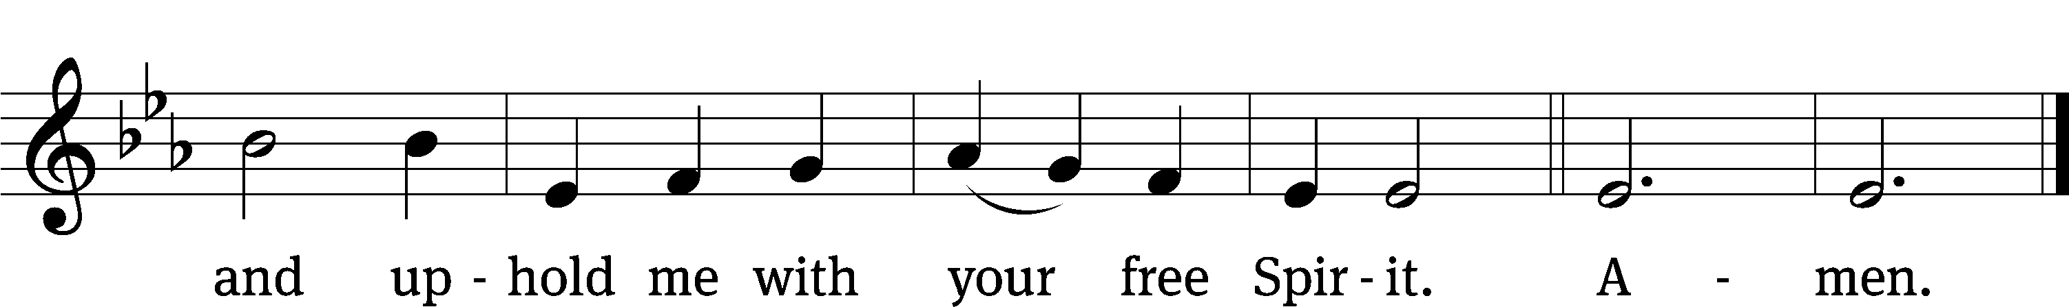
OFFERING
In response to God’s love and forgiveness, we give back a portion of what he has given us. The members of Christ Lutheran Church have joined to proclaim the gospel to this community. These offerings support that work. While our guests are welcome to participate, they should not feel obligated to do so.
PRAYER OF THE CHURCH
M: Lord God, like Thomas we wrestle with faith amid doubts and fears. Grant us Your Holy Spirit, that believing, we may see, and seeing, we may rejoice in Your Son and the power of His resurrection. Lord, in Your mercy,
C: Hear our prayer.
M: Gracious Lord, give courage to all pastors as they preach and teach the Word, that all who hear may believe and that, believing, they may live in righteousness and godliness until the day Christ returns as Judge and Lord of all. Lord, in Your mercy,
C: Hear our prayer.

M: Give peace, Lord, to our homes and enliven them by Christ’s resurrected life. Let the forgiveness of sins reign among husbands and wives, parents and children. Assure those who live alone that they, too, are Your children, upheld by Your right hand. Lord, in Your mercy,
C: Hear our prayer.
M: Lord God of hosts, You have added believers to the Lord Jesus in all times and places, from those receptive and hostile alike. Shepherd the nations, and bring all peoples to embrace the Gospel of the resurrected Christ. Curb wicked rulers and break their power, that all would be brought to the feet of Jesus in worship. Lord, in Your mercy,
C: Hear our prayer.
M: Gracious Father, as Your Son’s wounds brought gladness and peace to the troubled disciples, give Your presence and comfort to the troubled in our midst [especially _____________]. Comfort also those who weep [and especially _____________] with the blessed joy of Easter morning. Lord, in Your mercy,
C: Hear our prayer.
M: O Lord, preserve Your Holy Communion and Your Son’s blessed Supper among us. Give contrition and faith to those who gather at this altar. Unite them in their confession of Your truth, and so bring them worthily to eat and to drink Christ’s body and blood for their forgiveness and life. Lord, in Your mercy,
C: Hear our prayer.
M: Heavenly Father, Your Son suffered on our behalf to win salvation for us. Grant that we may have the privilege not only of believing in Him, but also of suffering for His sake. Renew us in the struggle against the temptations of the flesh and move us into a deeper understanding of the holiness which you have clothed us. Lord, in Your mercy,
C: Hear our prayer.
M: O Lord, heavenly Father, give us all things good and beneficial to us and to our salvation, and keep us from all things harmful; through Jesus Christ, our crucified and risen Savior, who lives and reigns with You and the Holy Spirit, one God, now and forever.
C: Amen.

LORD’S PRAYER Matthew 6:9-13; Luke 11:2-4
C: Our Father who art in heaven,
hallowed be thy name,
thy kingdom come,
thy will be done on earth as it is in heaven.
Give us this day our daily bread;
and forgive us our trespasses,
as we forgive those
who trespass against us;
and lead us not into temptation,
but deliver us from evil.
For thine is the kingdom, and the power,
and the glory forever and ever. Amen.

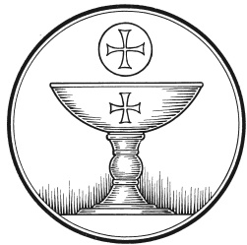
The Service of the Sacrament
This greeting marks a new service, so to speak. These ancient introductory words & phrases help to highlight, celebrate and bring attention to the Sacrament.
M: The Lord be with you.
C: And also with you.
M: Lift up your hearts.
C: We lift them up to the Lord.
M: Let us give thanks to the Lord our God.
C: It is good and right so to do.
M: It is truly good and right that we should at all times and in all places give you thanks, O Lord, holy Father, almighty and everlasting God, through Jesus Christ, our Lord, who by his willing sacrifice on the cross took away the sins of the world, and by his glorious resurrection restored everlasting life. Therefore with all the saints on earth and hosts of heaven, we praise your holy name and join their glorious song:

HOLY, HOLY, HOLY – Sanctus
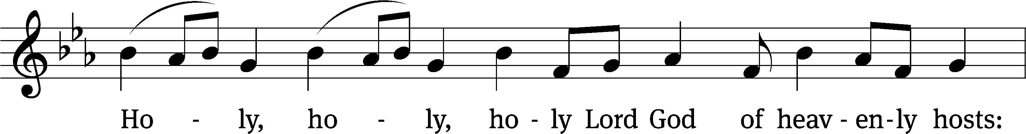
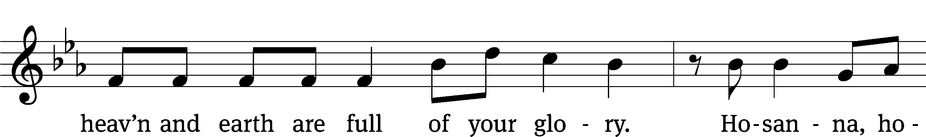
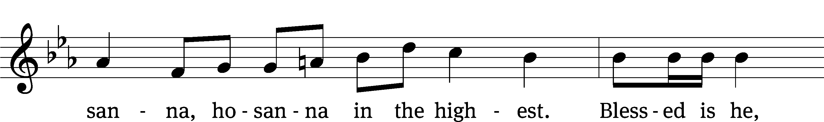
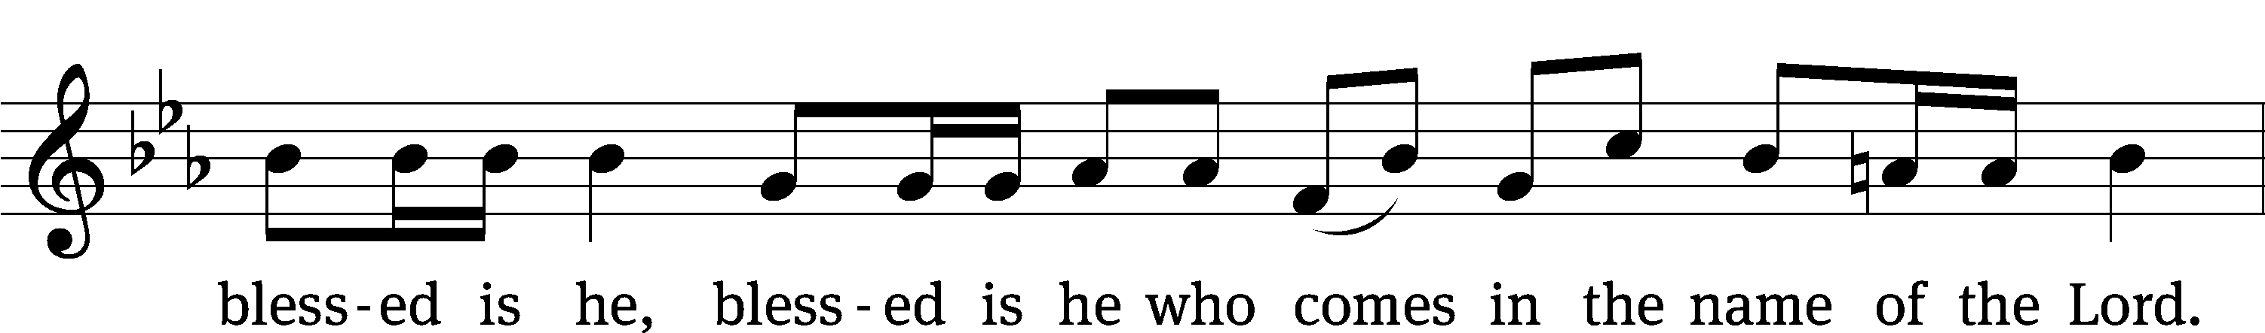
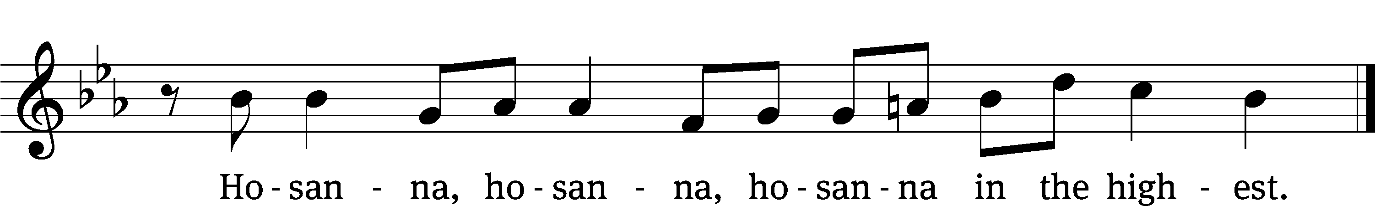
WORDS OF INSTITUTION Matthew 26, Mark 14, Luke 22
M: Our Lord Jesus Christ, on the night he was betrayed, took bread; and when he had given thanks, he broke it and gave it to his disciples, saying: “Take and eat. This is my ✙ body, which is given for you. Do this in remembrance of me.”
The Words of institution both proclaim the words of Jesus to the congregation and sets apart the bread and wine for the Lord’s Supper.
Then he took the cup, gave thanks, and gave it to them, saying, “Drink from it all of you; this is my ✙ blood of the new covenant, which is poured out for you for the forgiveness of sins. Do this, whenever you drink it, in remembrance of me.”

PEACE OF THE LORD – Pax Domini John 20:19
M: The peace of the Lord be with you always.
C: Amen

O CHRIST, LAMB OF GOD – Agnus Dei John 1:29
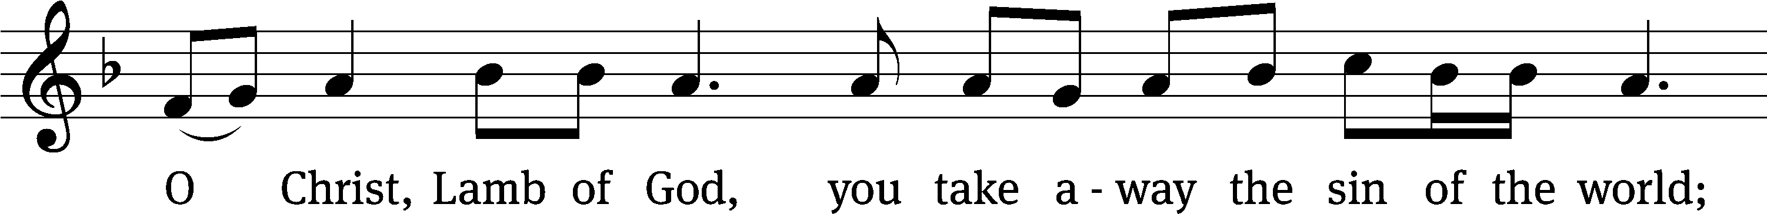
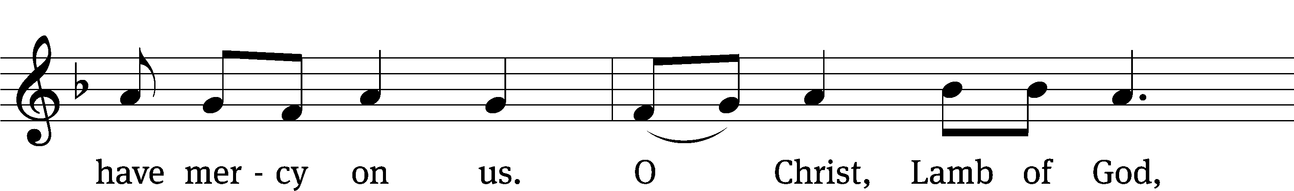
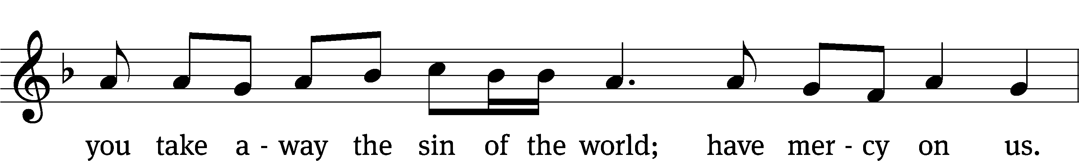
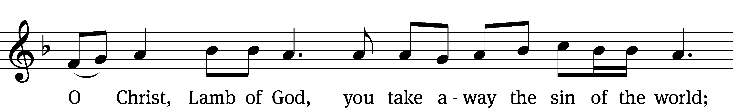
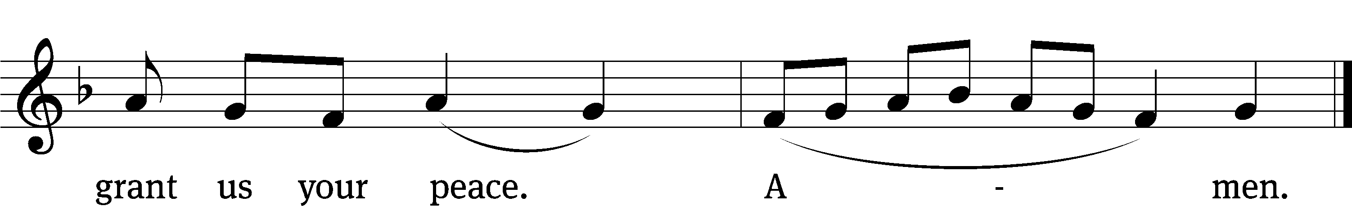

DISTRIBUTION
Those who will be receiving Holy Communion today may wish to read Personal Preparation for Holy Communion, found on page 295 in the front section of the hymnal. This page helps us put into practice what the Bible encourages: “Everyone ought to examine themselves before they eat of the bread and drink from the cup.” (1 Corinthians 11:28)
Christ Lutheran Church confesses and practices the Biblical teaching of a Closed Communion. We ask that only members of the Wisconsin Synod [WELS] or the Evangelical Lutheran Synod [ELS] join us at the Lord’s Table. If you have questions concerning our communion practice, or would like to inquire about how you, too, can commune with us, please speak with the Pastor following the service.
During the Distribution, the congregation may join to sing Hymn 676: Take and Eat

THE SONG OF SIMEON
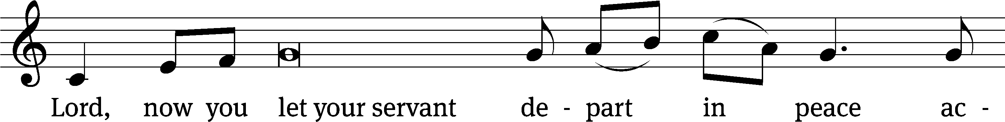
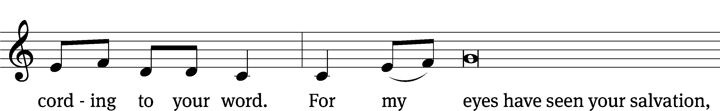
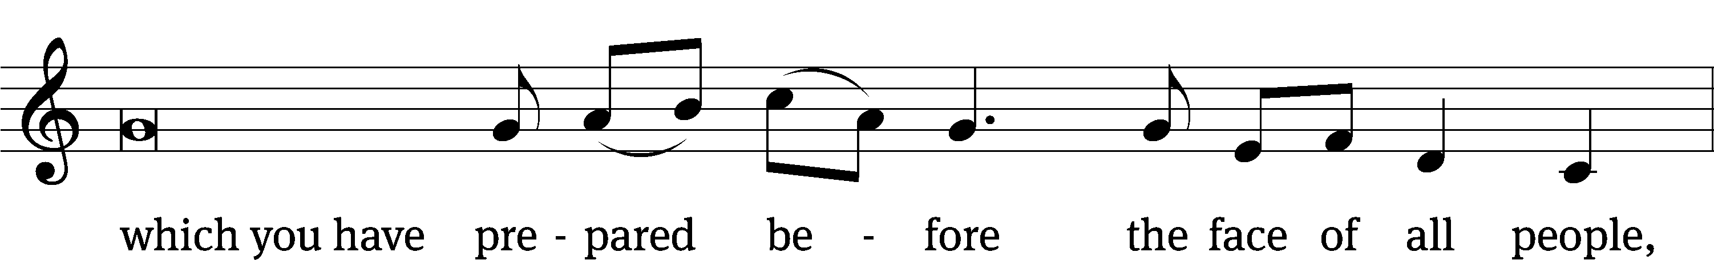
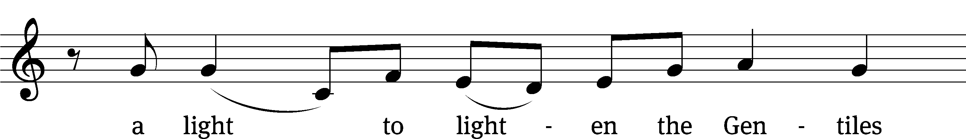
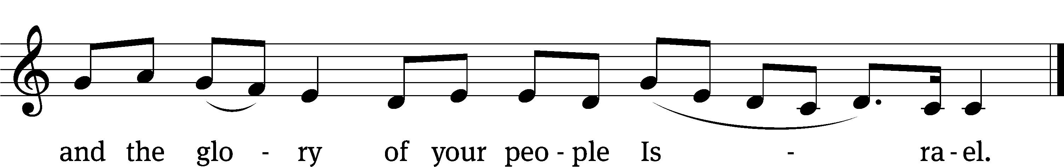
M: We give thanks, almighty God, that you have refreshed us with this holy supper. We pray that through it you will strengthen our faith in you and increase our love for one another. We ask this in the name of Jesus Christ, our Lord, who lives and reigns with you and the Holy Spirit, one God, now and forever.
C: Amen.

THE BLESSING
M: The Lord bless you and keep you.
The Lord make his face shine on you and be gracious to you.
The Lord look on you with favor and ✙ give you peace.
C: Amen.
CLOSING HYMN We Walk By Faith| CW 830

COPYRIGHT INFORMATION
Content requiring a copyright license is reproduced under OneLicense.net #A-718312. All rights reserved. The Common Service: Texts revised from The Lutheran Hymnal, 1941. Music revised by James Engel. Scripture Quotations: From the Holy Bible, New International Version (NIV 1984), © 1973, 1978, 1984 by Biblica, Inc.

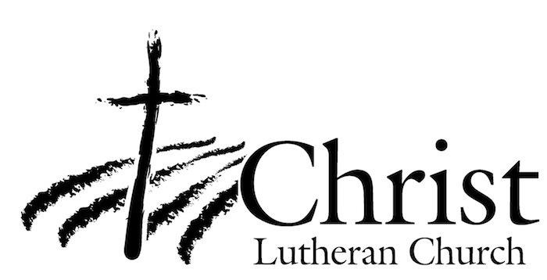
13009 N. Elderberry Ct.
Lodi, CA 95242
www.christlodi.org
209-368-6250
Pastor Timothy Leistekow
WELCOME TO CHRIST EV. LUTHERAN CHURCH!
We preach a message of forgiveness, hope and peace
through the death and resurrection of Jesus Christ.
Families and individuals of all ages will find opportunities
both to grow and to serve.
Our mission statement:
Look what Christ is doing!
He binds us together in fellowship
He gathers us in for worship
He builds us up for service
He sends us out with the gospel

“Now you are the body of Christ,
and each one of you is a part of it.”
(1 Corinthians 12:27)

